

Year 7 Transition 1 – ICT Task 2

Famous Australian Scientists

Learning Intention:

Success Criteria:

Use the five steps to research and filter information (clarify, search, investigate, evaluate, and cite) to complete this ICT task.

Famous Australian scientist - Struan Sutherland

What big questions do you want to investigate about Struan Southerland?

- Your research topic is ‘Struan Sutherland’.

- Write as many different big questions as you can think of relating to the topic.
How did he manage the risks of venomous? organisms?

What are some of Struan’s biggest accomplishment?
What did he investigate?

Research topic: Struan Sutherland

Write your question here ….
How has his discovery changed our lives?
Write your question here ….

What are the best words you can type into the search engine to get the highest quality
results?

- Underline the keywords in each question.

  - What did he investigate?

  - How did he manage the risks of venomous organisms?

  - What are some of Struan’s biggest accomplishments?

  - How has his discovery changed our lives?

  - Your question 1

  - Your question 2

What are some of Struan’s biggest achievements?
Knowing how to effectively take notes is necessary for interpreting, organising, summarising and memorising information. Effective notetaking is important to help you to retain information. Having good notes will play an important role in helping you maximise your science results.
- Use the table below to help you organise your notes. On the right side is the note-taking column. This is where you write brief summarised notes. On the left side is your Key word or Prompt column. Here you write key words from your notes or other prompts to help you.

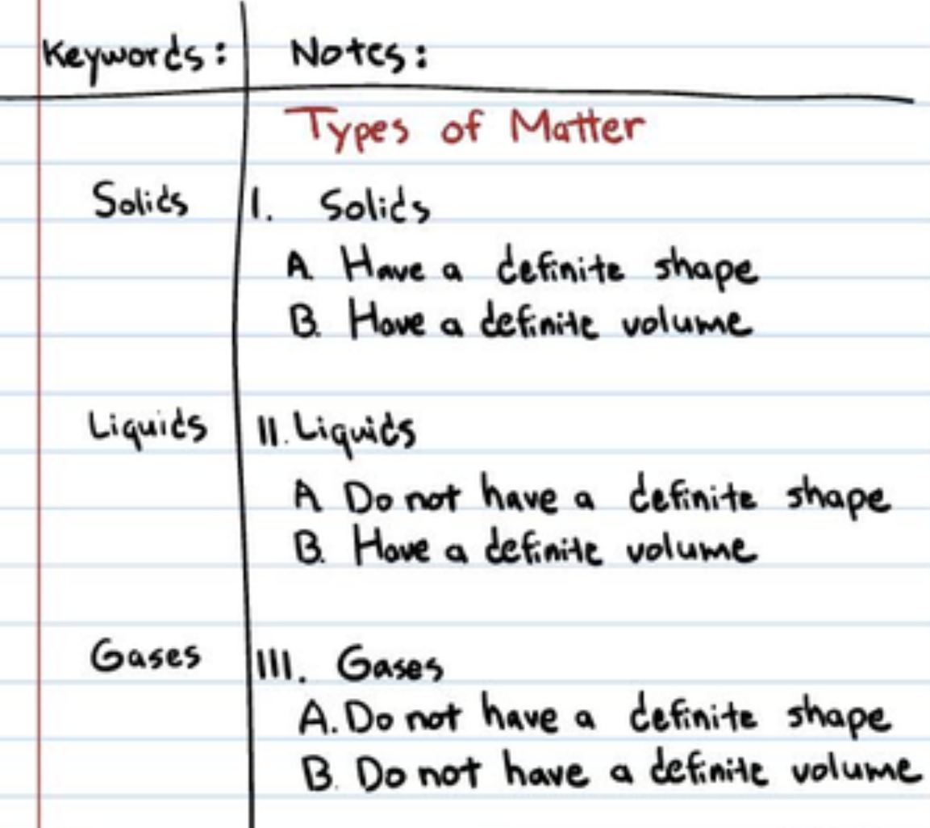

- Use the tables below to organise your notes for each of the big questions about Struan Southerland.

  - What did he investigate?

Keywords | Notes

  - How did he manage the risks of venomous organisms?

Keywords | Notes

  - What are some of Struan’s biggest accomplishments?

Keywords | Notes

  - How has his discovery changed our lives?

Keywords | Notes

  - Your question 1

Keywords | Notes

  - Your question 2

Keywords | Notes

References
Surname | Initial | Title of page | Full title of website | Date Written | Internet Address | Date of visit
Brown | J. | ‘Things in Space’ | Astronomy Facts | 1998 | http://www.astronomyfacts.com | 31 July 2019

